

My communication preferences [name]

Add my photo here | Describe what is happening in this photo.  Where am I? Who with? What am I do? Etc
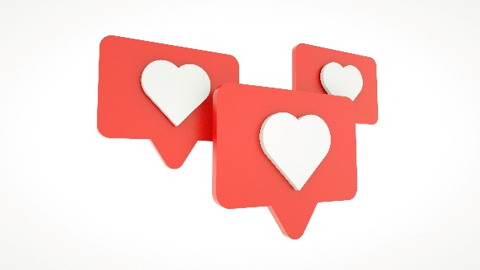 | What people like about me  - Describe what you like about me – this could be aspects of my personality or my strengths
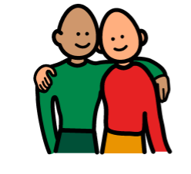 | Building a relationship with me  - Describe how to get to know me. How do you make me laugh and smile? How do you bond with me? What makes our relationship special?
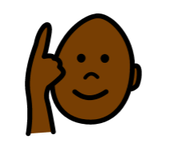 | Helping me understand  - Describe how I understand as well as the things I need to help me understand – e.g. spoken or written words, pictures, photos, objects of references, signs, gestures, facial expressions, phone of voice – which of these help and which ones are confusing for me?  - What does the communication partner need to do? E.g. pause so I can process it, one thing at a time, gesture at the same time, simple words, single words?
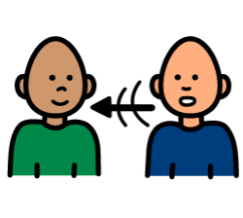 | Helping me tell you my views and wishes  - How do I communicate? If I do not speak words, what are the clues about what I am communicating? Do I need pictures, signs etc to help me?
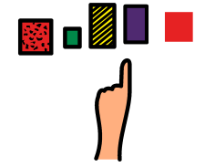 | Helping me make choices  - What helps me to make choices? Is visual support easier for me?  - Do I get stressed in making choices? Do you need to ask in a particular way?
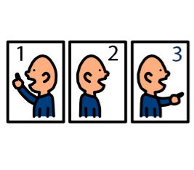 | Telling me about my day  - Do I need visual support to understand routines e.g. now and next board, visual timetable, clinician rota, calendar  - How much preparation do I need for changes and transitions?
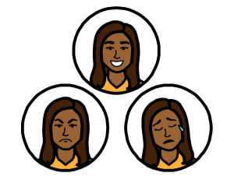 | Spotting how I am feeling  - Describe my appearance and behaviours when I am happy, sad, angry, hungry, tired, need the toilet, in pain  - Am I able to use a body map, pain scales or emotional zones of regulation?  - Do I have a PBS plan with more details?
 | Things that bring me joy  - This could be sensory joy and stimming, activities, people or places. What makes my face light up and my body feel relaxed?
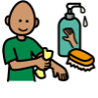 | My sensory preferences & needs  - Include sensory seeking as well as sensory avoidance  - Do I need a sensory assessment – can you link this care plan to a sensory needs plan?
 | Helping me feel OK  - What helps me feel better – distraction? Keeping me busy? Proactive risk-taking, balancing sensory/social diet? Balancing energy ‘spoons’?
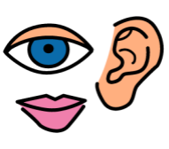 | Communication environment  - Do I like to have labels on cupboards and drawers to help me with household chores – where to put my clothes or the shopping.  - Do visual schedules help me be more independent eg morning routine schedule? Step by step instructions
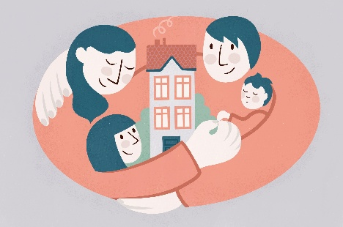 | Making me feel safe  - What makes me feel safe? Do I need a lot more help to trust others? What helps?

